Education based website

Topic: Education

**Olivia Summerville Mullen**

**Grace Fitzgerald**

**Sean Kerrigan**

CS335 Software Engineering & Software Process



Department of Computer Science

Maynooth University

Maynooth, Co. Kildare

Ireland

Education based website

## Table of Contents

Table of Contents 2

Abstract 2

User Stories 3

3.1: Scenario 1: 3

3.2: Scenario 2: 3

3.3: Scenario 3: 3

3.4: Scenario 4: 3

3.5: Scenario 5: 3

3.6: Scenario 6: 3

3.7: Scenario 7: 3

3.8: Scenario 8: 4

3.9: Scenario 9: 4

3.10: Scenario 10: 4

3.11 Scenario 11: 4

3.12 Scenario 12: 4

Use Case Diagram 4

Class Diagrams 5

Sequence Diagrams 7

Architecture Diagrams 11

UI Design 13

System Tests 13

## Abstract

The idea behind the project was to create a software system which can be used for an educational purpose. Regular users can access calendar while being able to create, delete and star events along with creating a new calendar if necessary. They can access the module page where they have option to upload assignments and voice their opinion on class discussion forum. They also have the use of Messenger where they can utilise all what we have to offer from creating a group, user or meeting, message group or user, delete chats or group and start a call. From settings the user can change language to their preference and edit accessibility, display settings, notification. Then they can access Homepage which allows them to few useful links, access help, edit user profile and access timetable. The Educator can do additional features like create a module, add content, remove content, add assignment submissions.

Work Contributions:

User Stories – Sean

Class Diagram – Olivia, Grace and Sean

Sequence Diagrams-Olivia, Grace and Sean

Architecture Diagrams-Olivia, Grace and Sean

UI Design– Grace

System Tests-Olivia

## User Stories

3.1: Scenario 1: John is a student with a vision impairment. He would need to have the fonts be enlarged to accommodate his impairment.

3.2: Scenario 2: Agnes is a mature student in her 60s who has not used much technology prior to entering the University. As such, she would need easy access to IT services when she would be there.

3.3: Scenario 3: David is a student with dyslexia. He would need 1. A screen reader to read out some words to him, and 2. Font options to be able to distinguish letters more easily.

3.4: Scenario 4: Yvonne is a lecturer who has some assignments to set her various students. She would need options to set visibility and submission for these assignments so that students do not have any unfair advantage with time.

3.5: Scenario 5: Jack, Jill and James are all assigned a group for a project. To talk to their team members, they will a way to communicate via text and call.

3.6: Scenario 6: Susan is a Student who is rather concerned with exam revision. To understand the layout, she needs quick access to previous exam papers.

3.7: Scenario 7: The timetable office of a university may need to communicate with all the different departments about what rooms are taken by who and when. Therefore, they will need to be easily reached out to via the app to let both lecturers and students know.

3.8: Scenario 8: Support services on campus may want to work around some student’s timetable. To reduce their workload, they should be able to cross reference timetables with via the app to prevent clashes.

3.9: Scenario 9: Martina is an international Student, who speaks English as a second language and would prefer to use Spanish. To prevent issues, they should be able to change the languages via settings.

3.10: Scenario 10: Daniel is a Student who likes to stay organised and on top of upcoming events, he will need a calendar he can tailor to display modules, exams, assignments or custom events.

3.11 Scenario 11: Hannah is a student who finds herself confused on some topics in a module, she feels her peers can help her so she would like a way to ask them all a question and let anyone reply to her. She would like to submit the question anonymously.

3.12 Scenario 12: Mark is a tutor who is required to help students when they need it, he would need an easy to use system where students can post questions and he can choose which ones to answer depending on if its in his level of expertise.

## Use Case Diagram

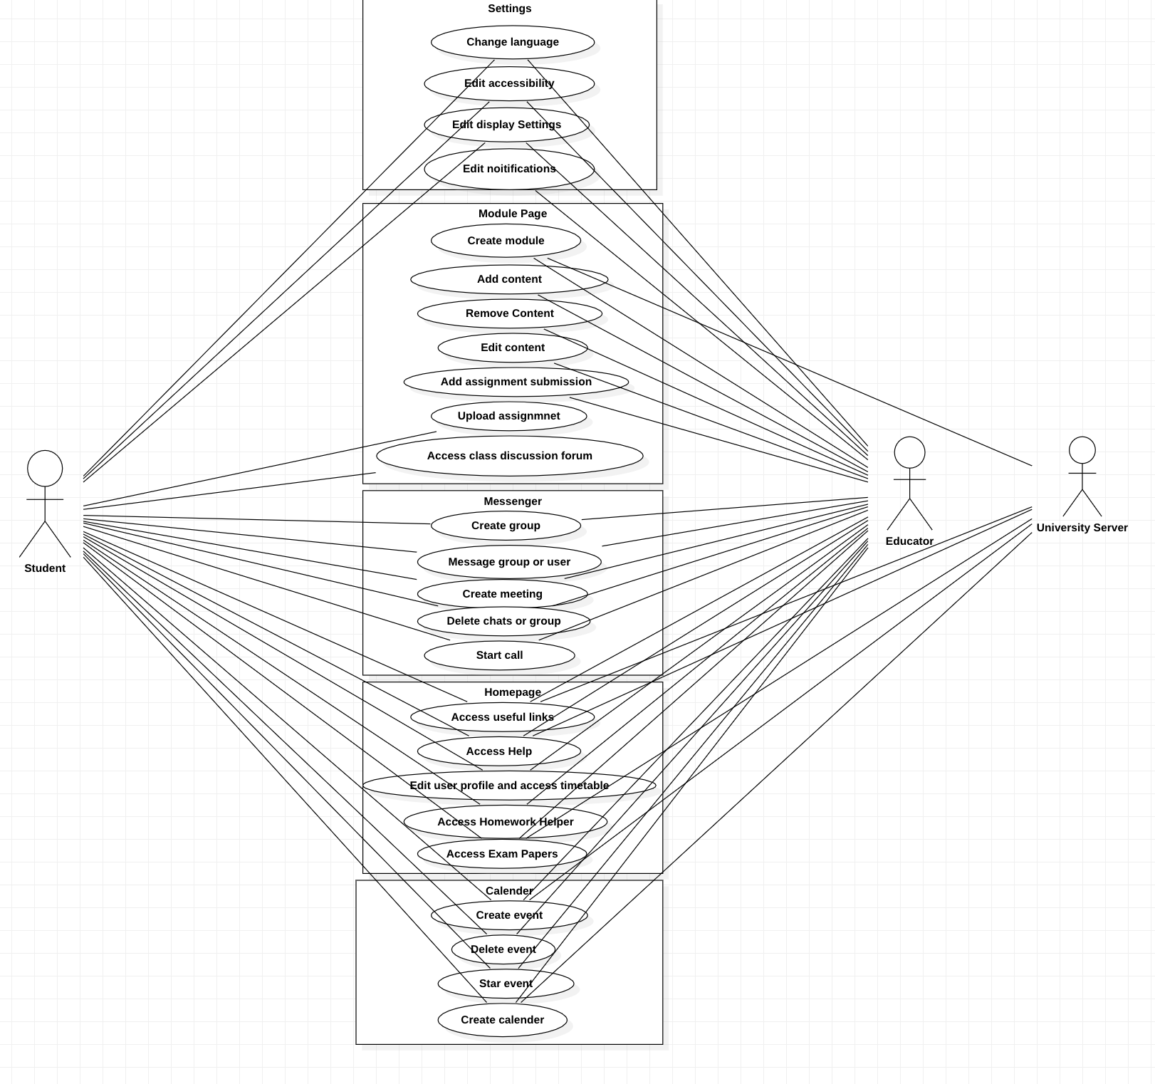

Fig 5.1 Use case diagram for whole system.

## Class Diagrams

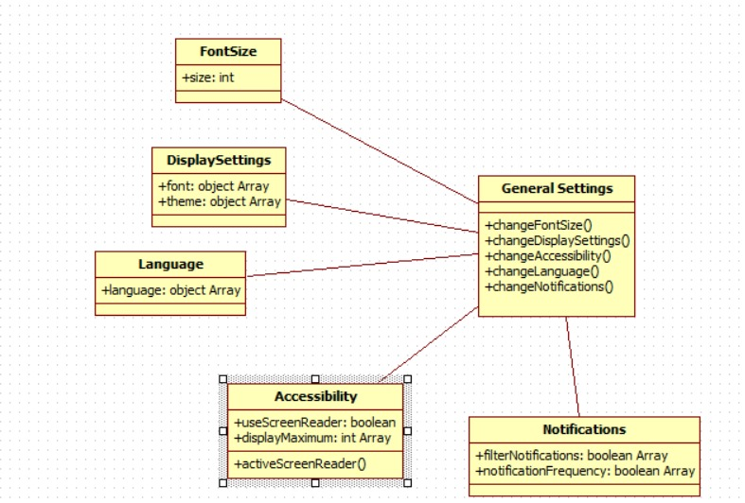

Fig 5.1 Settings

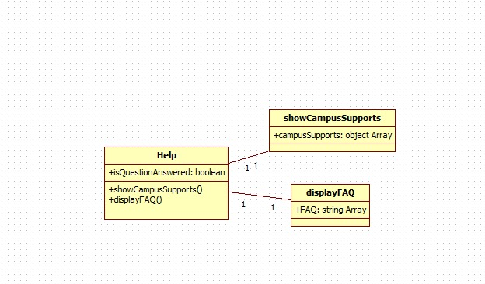

Fig 5.2 Help

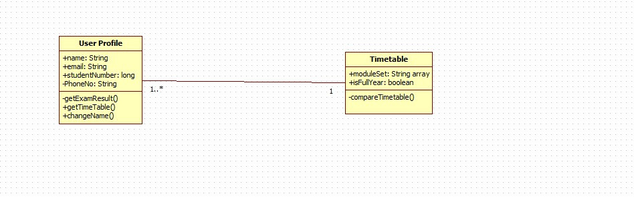

Fig 5.3 User Profile

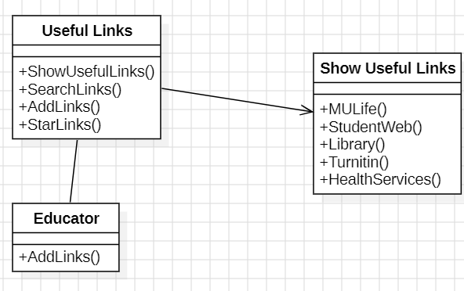 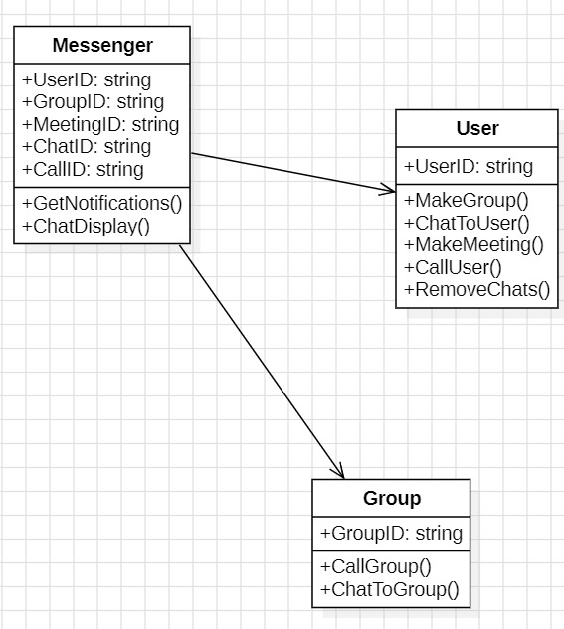

Fig 5.4 Useful Links Fig 5.5 Messenger

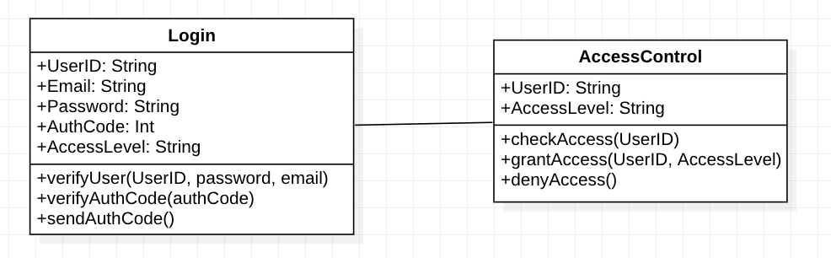

Fig 5.6 Login Class Diagram

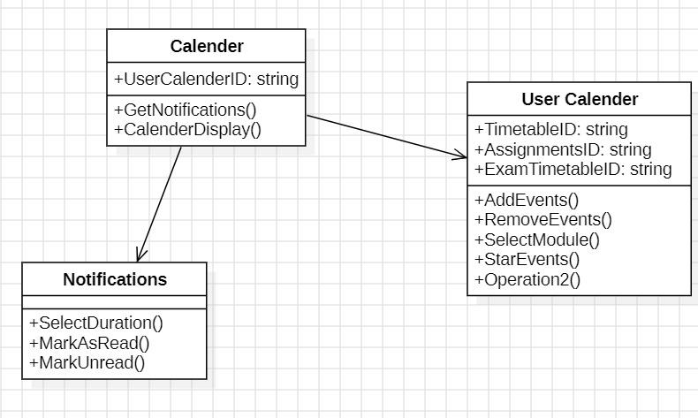 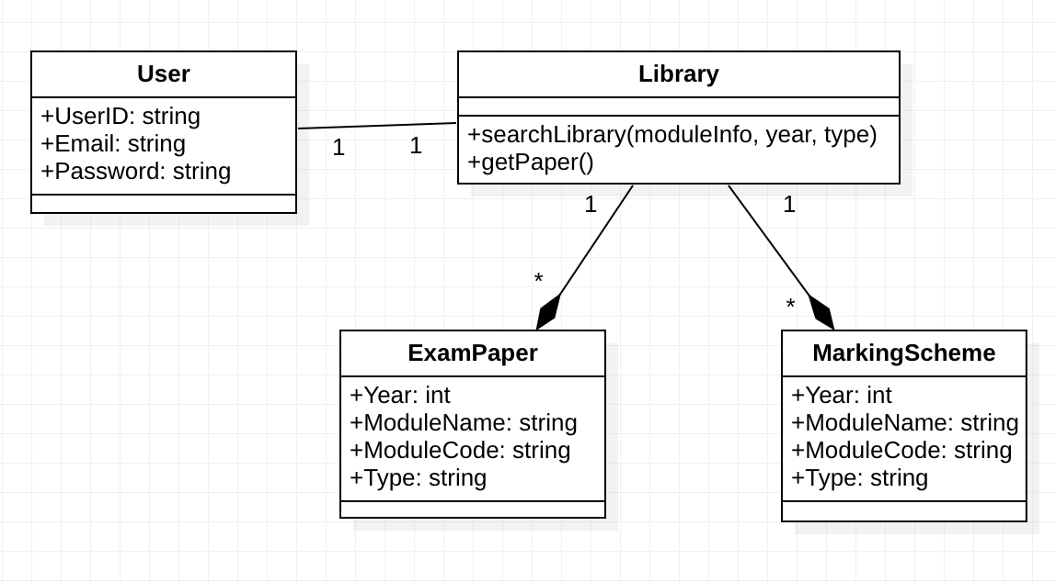

Fig 5.7 Calendar Fig 5.8 Exam Papers

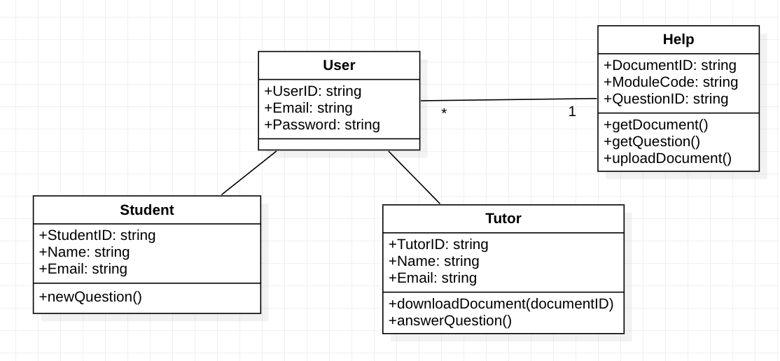 Fig 5.9 Homework Helper

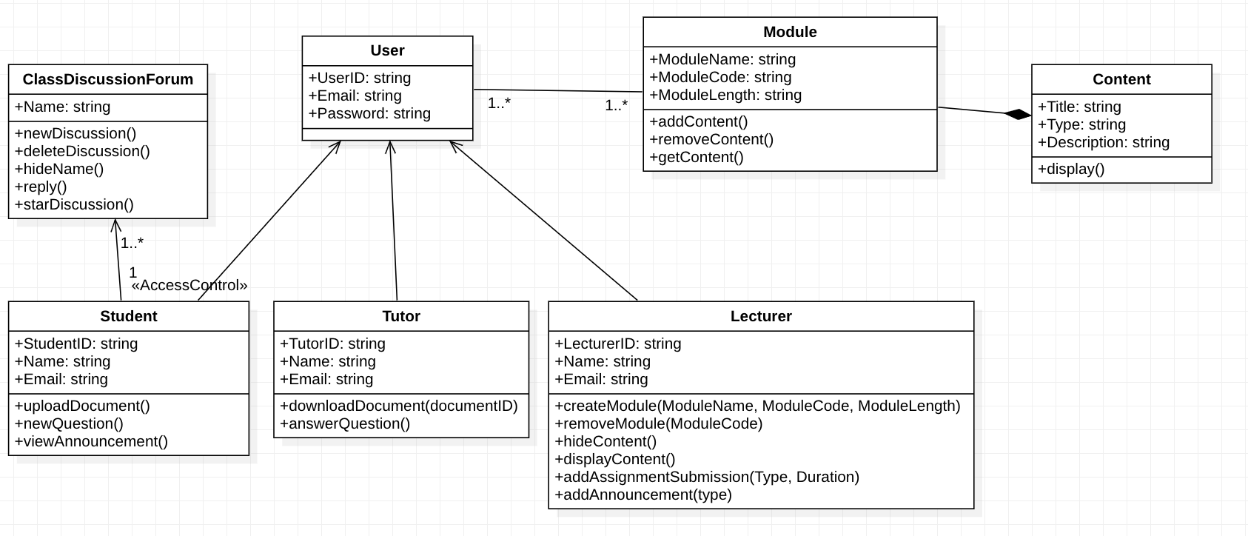

Fig 5.10 Module

## Sequence Diagrams

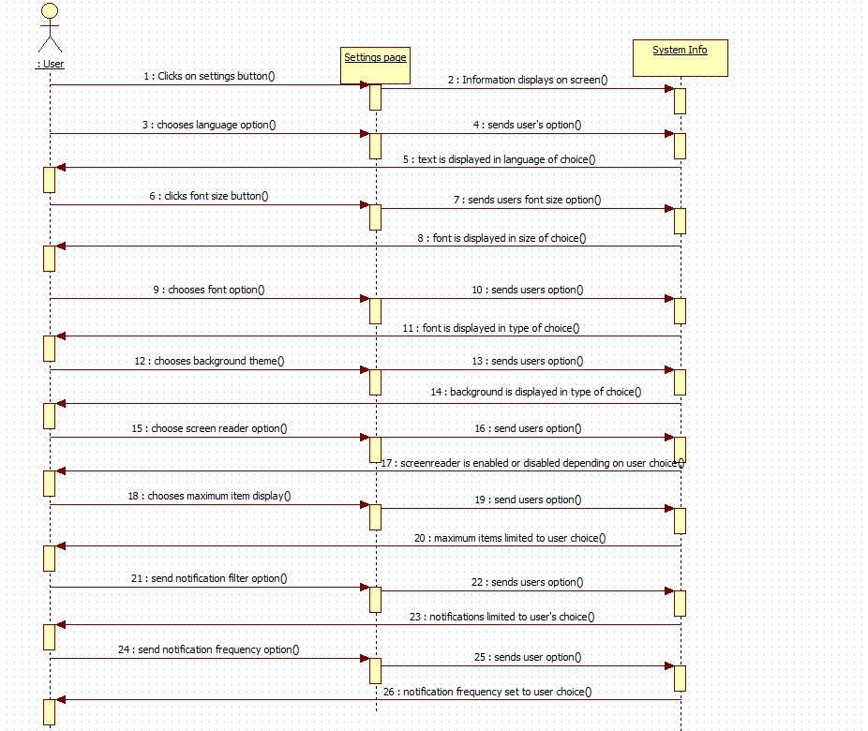 Fig 6.1 User editing various settings.

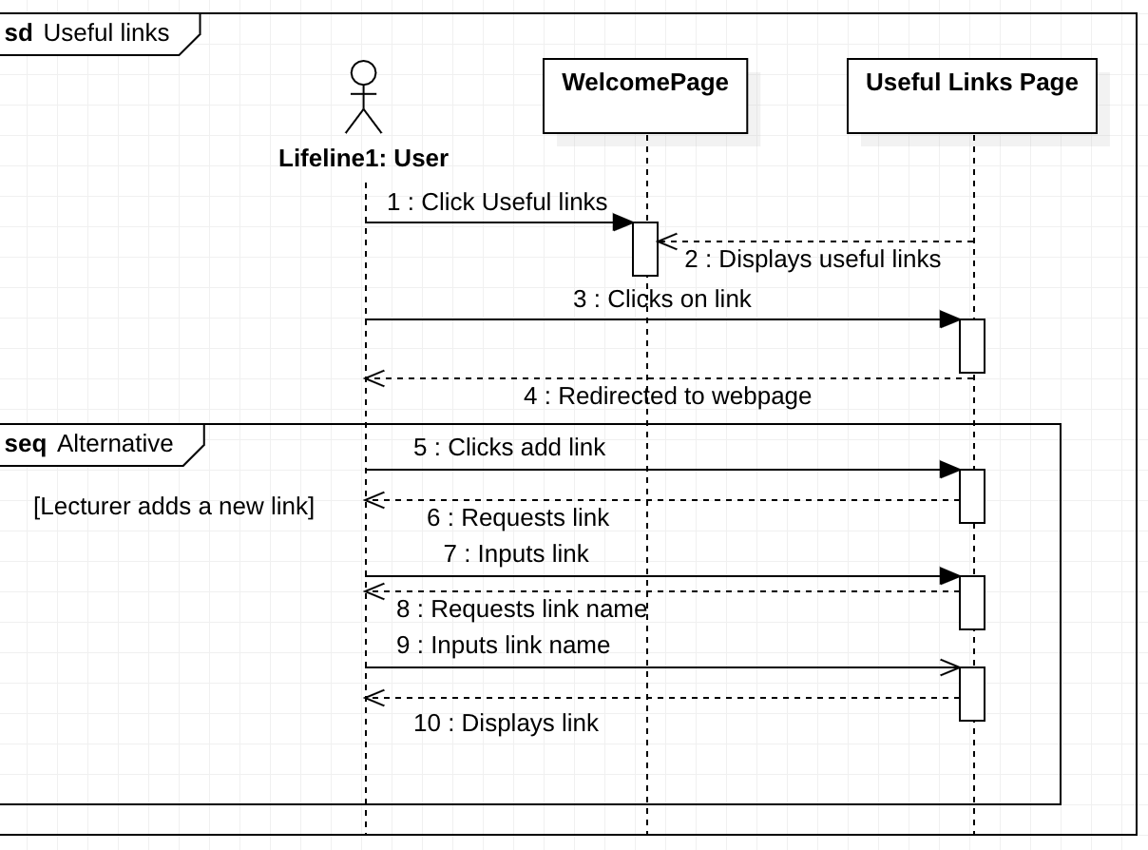 Fig 6.2 User clicking on a useful links and a lecturer adding one to the system.

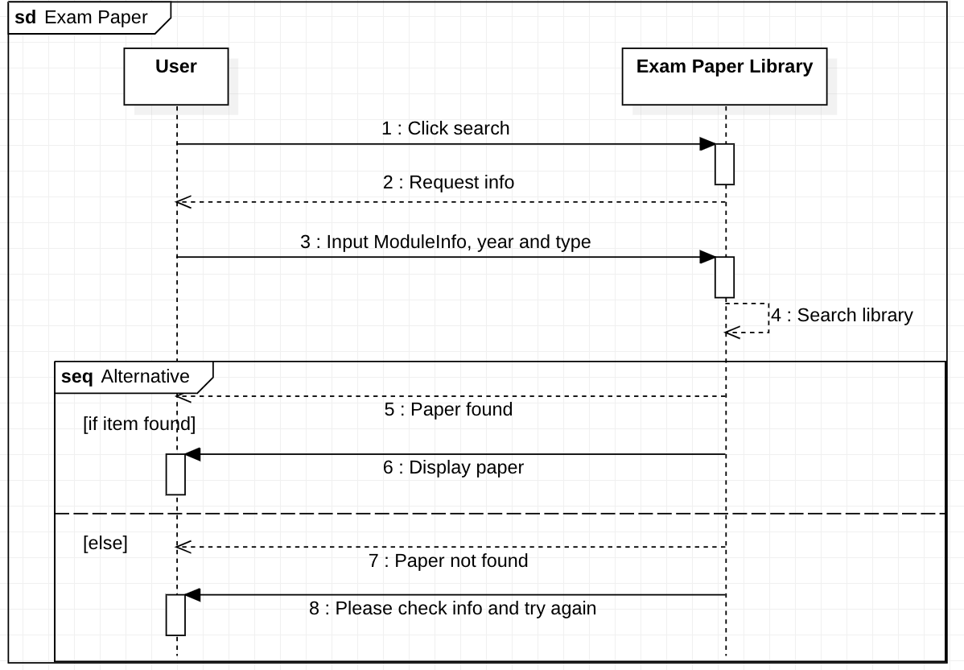 Fig 6.3 User searches for exam paper or marking scheme.

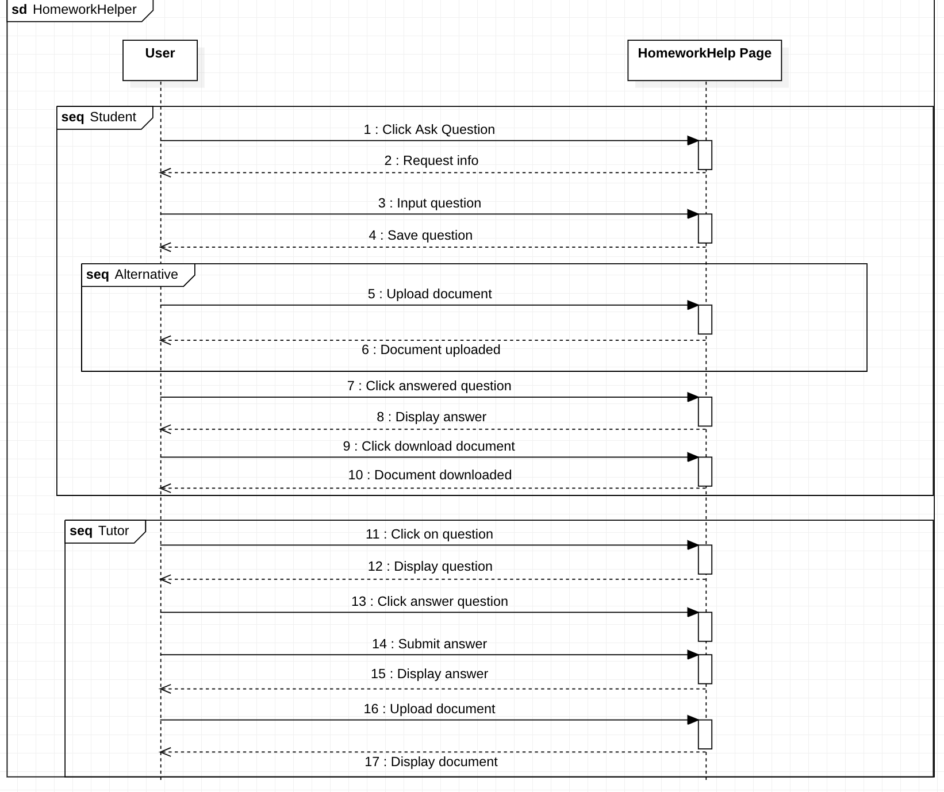 Fig 6.4 Student and Tutor using the homework helper.

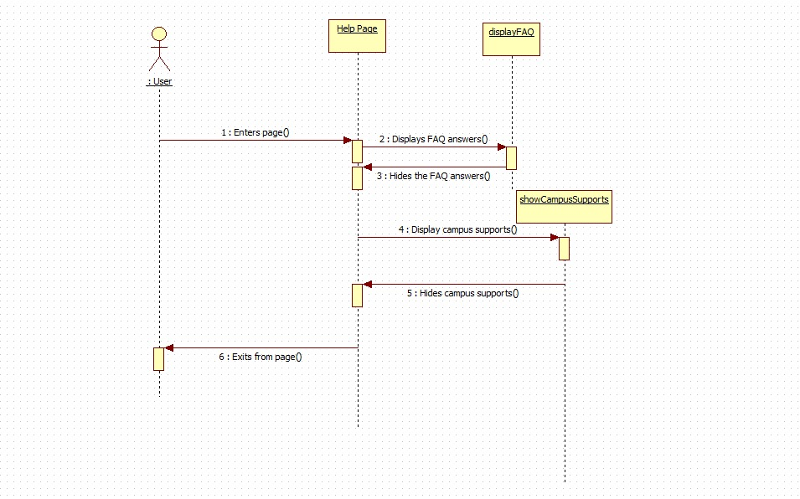 Fig 6.5 User visiting FAQ. 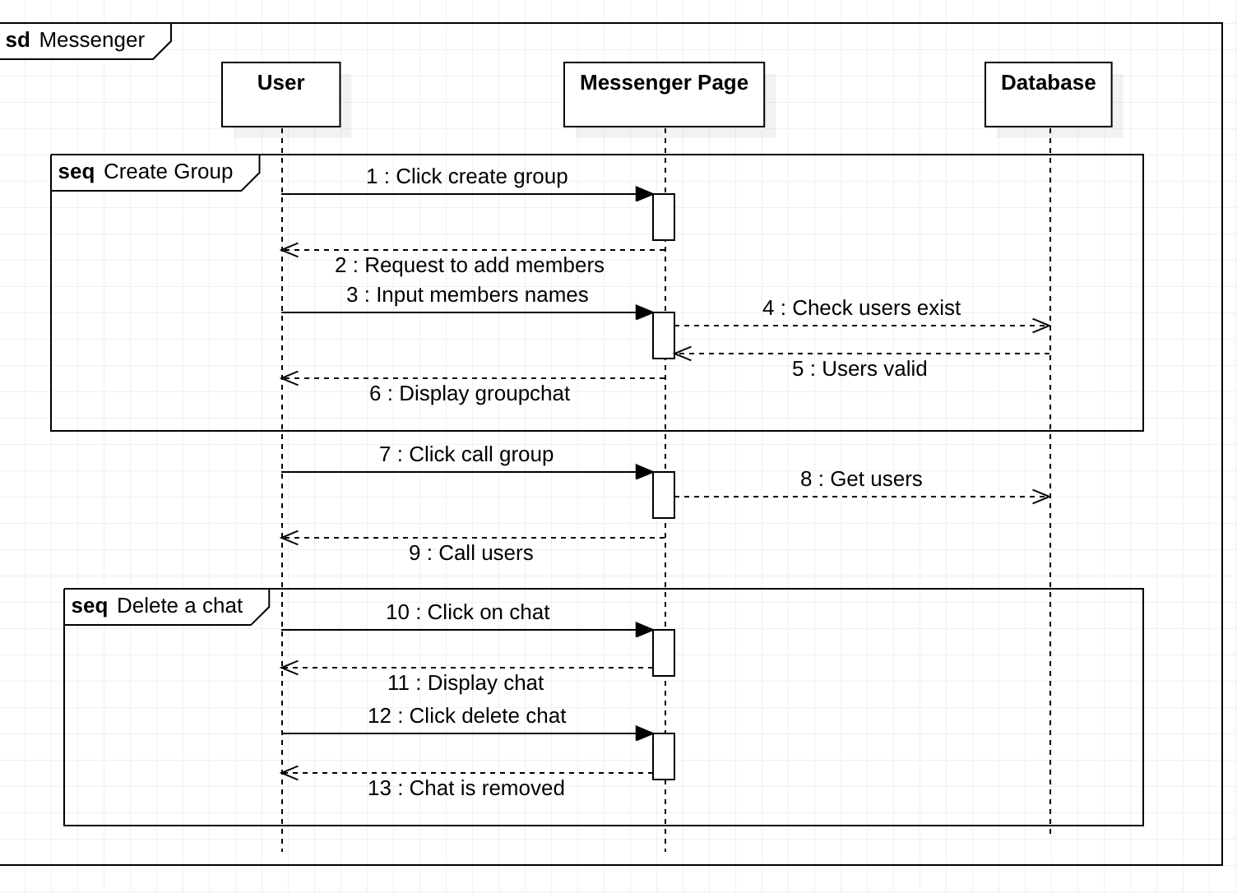

Fig 6.6 User creating a group, calling and deleting a. chat in messenger

.

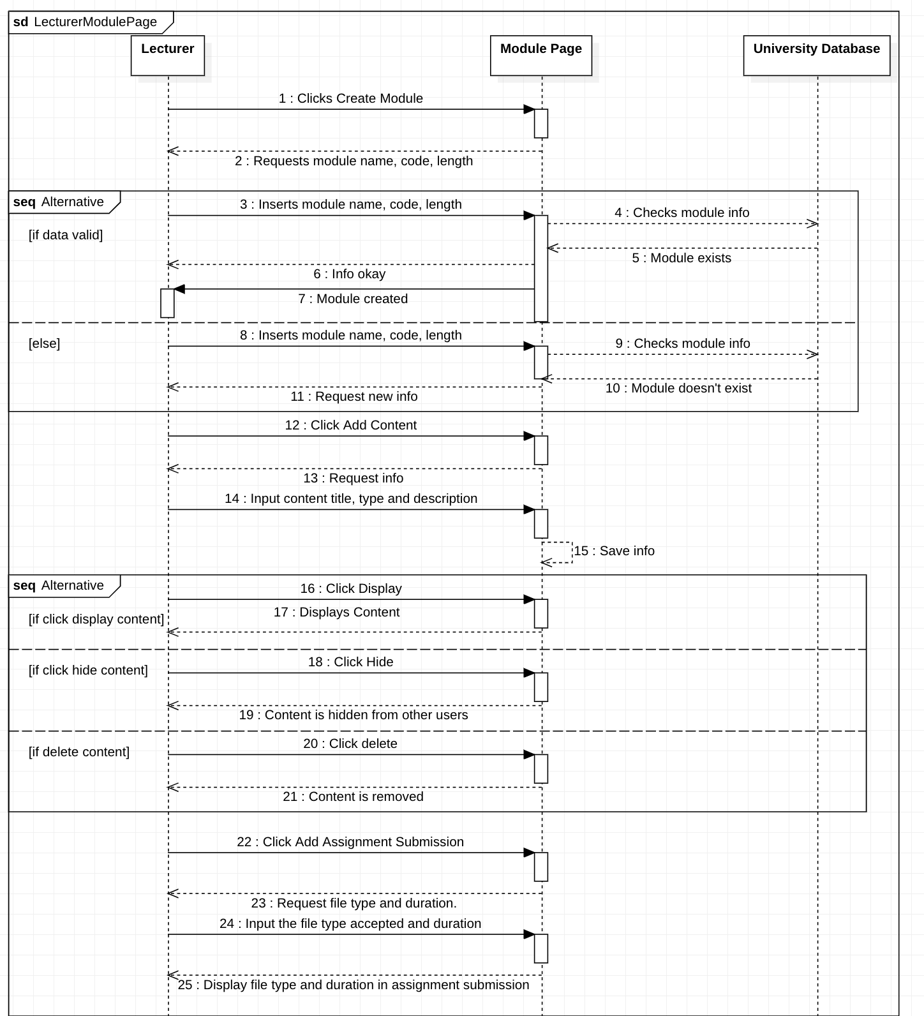

Fig 6.7 Lecturer carrying out various functions on the module page.

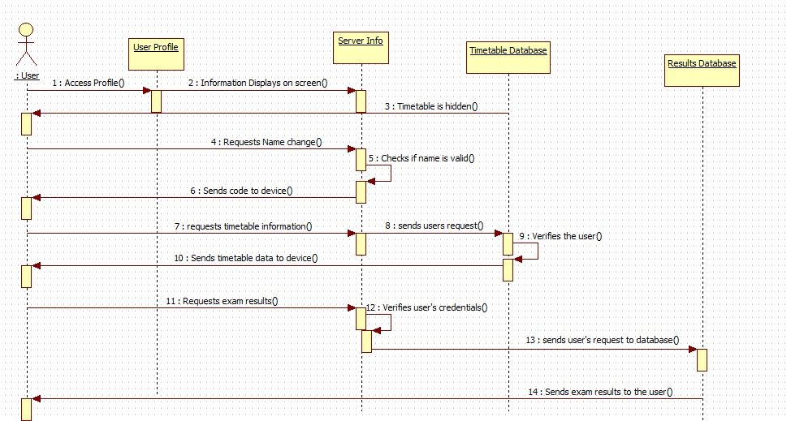 Fig 6.8 User making use of functions in profile settings

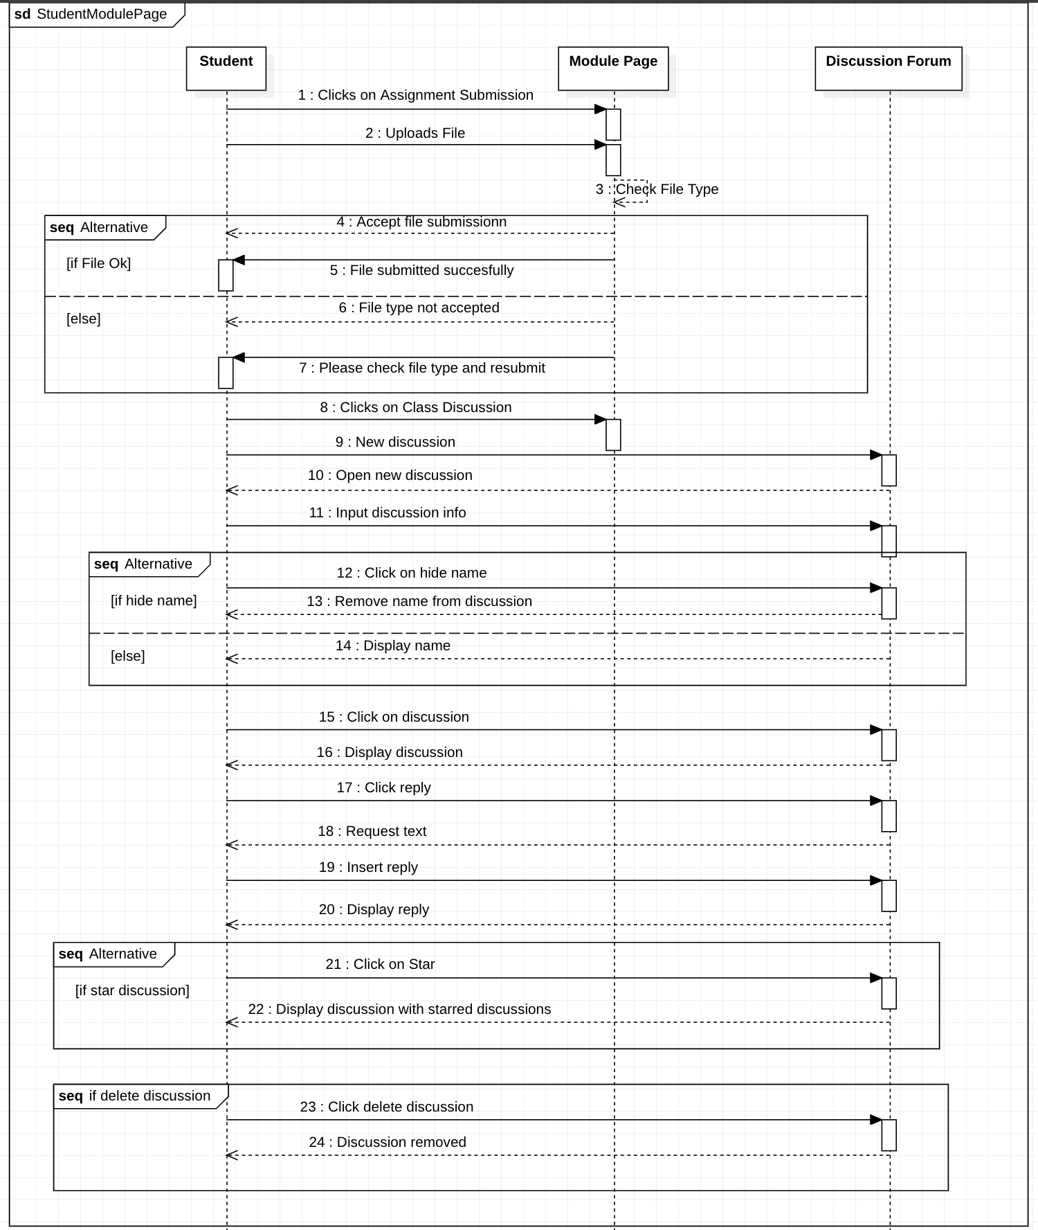 Fig 6.8 Student uploading assignment and interacting with class discussion forum.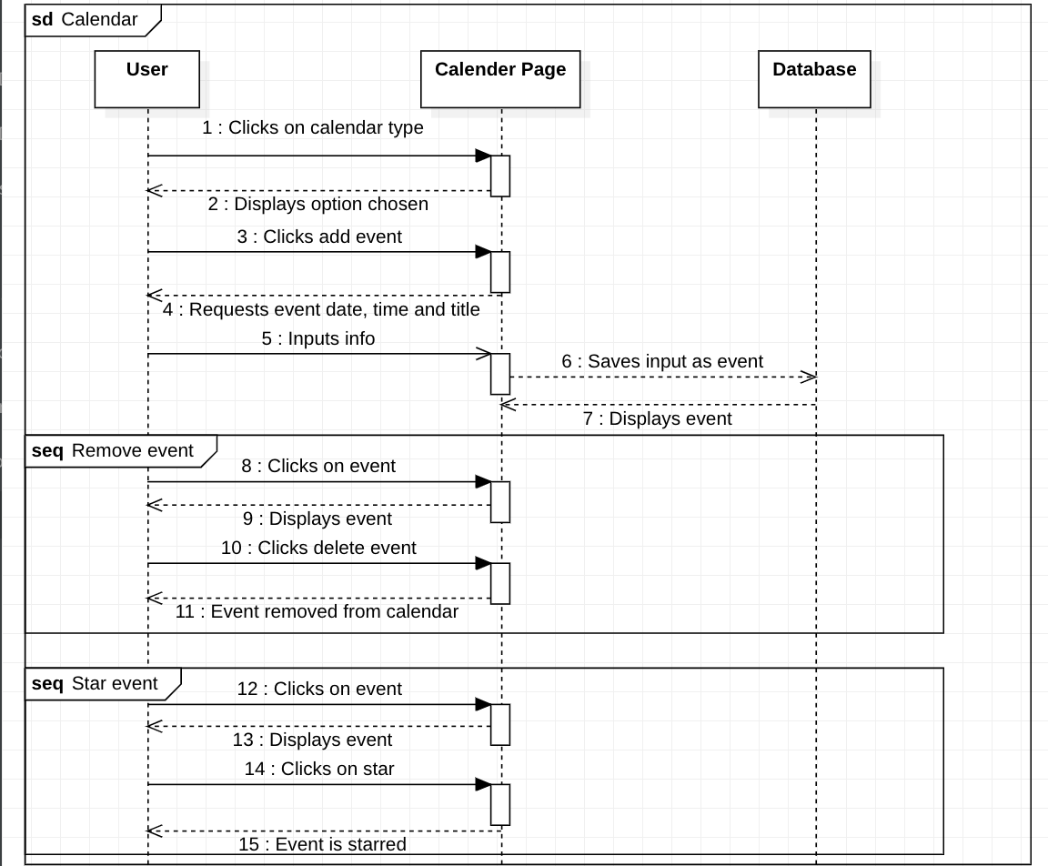 Fig 6.9 User viewing calendar of choice and editing events.

## Architecture Diagrams

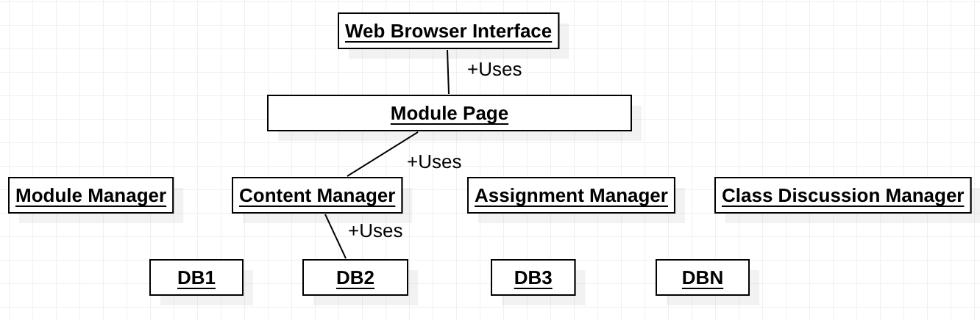

Fig 7.1 Module Page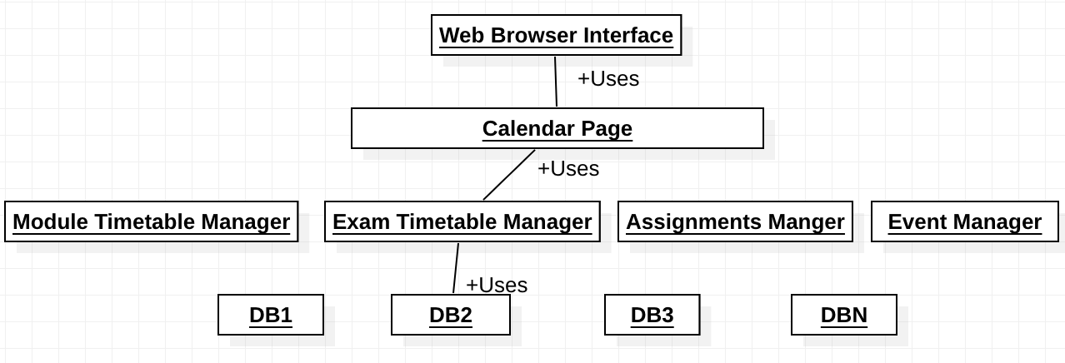

Fig 7.2 Calendar Page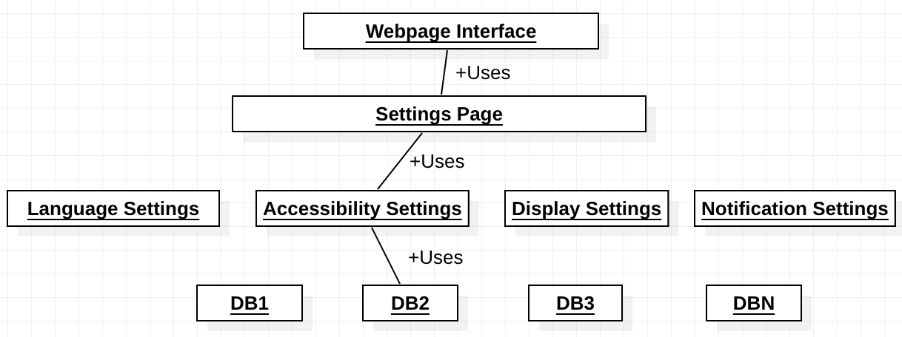

Fig 7.3 Settings Page 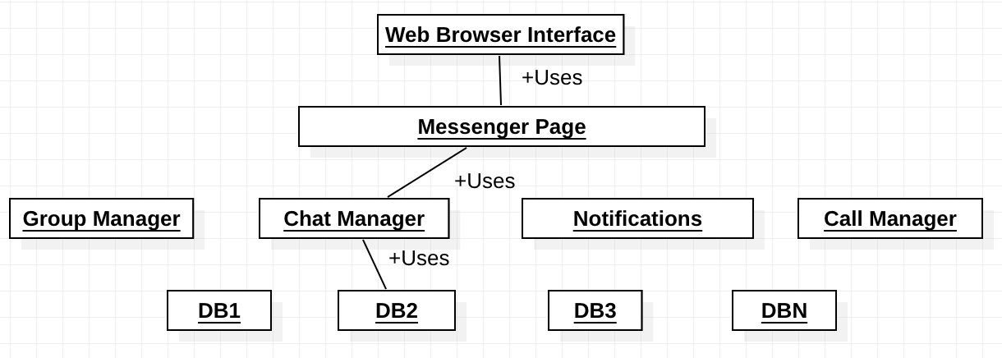

Fig 7.4 Messenger Page

## UI Design

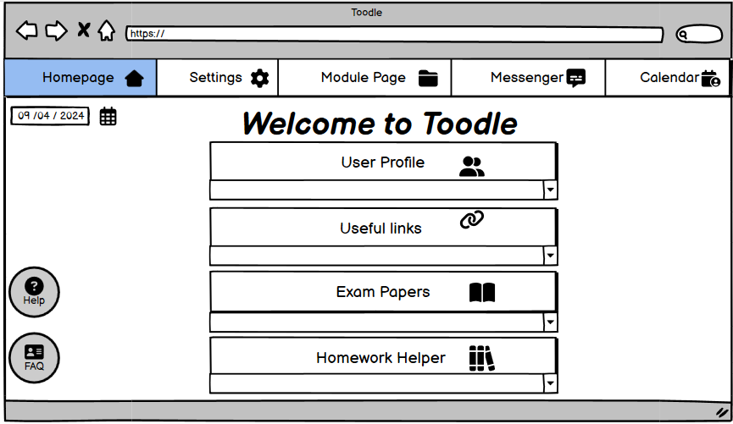 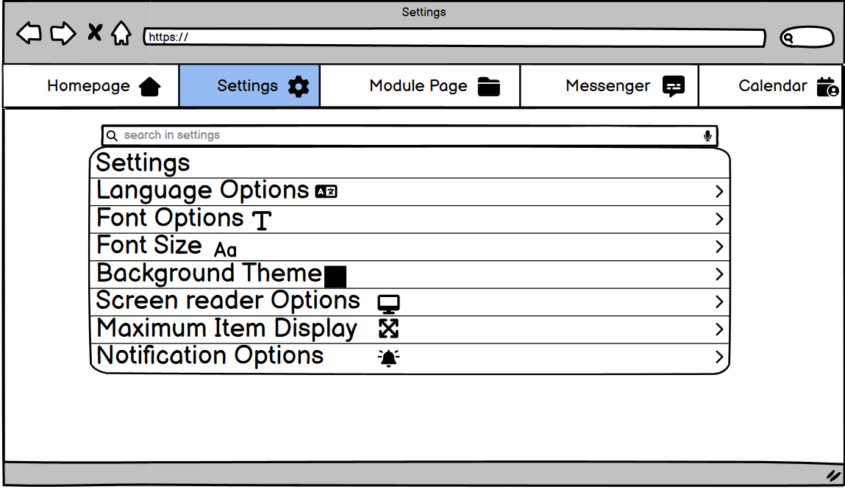

Fig 8.1 Welcome Page Fig 8.2 Settings Page

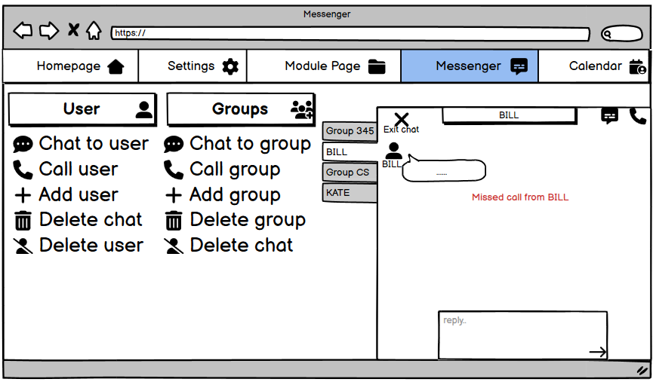 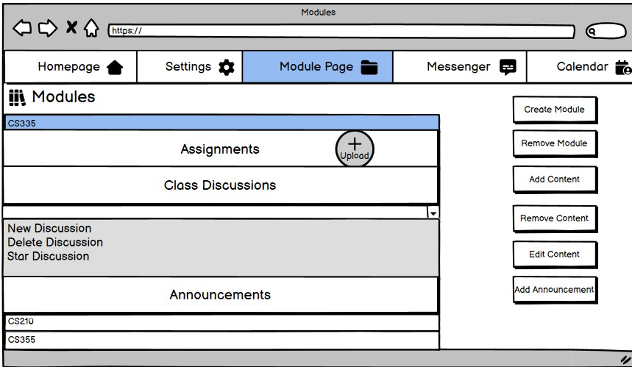 Fig 8.3 Messenger Page Fig 8.4 Module Page 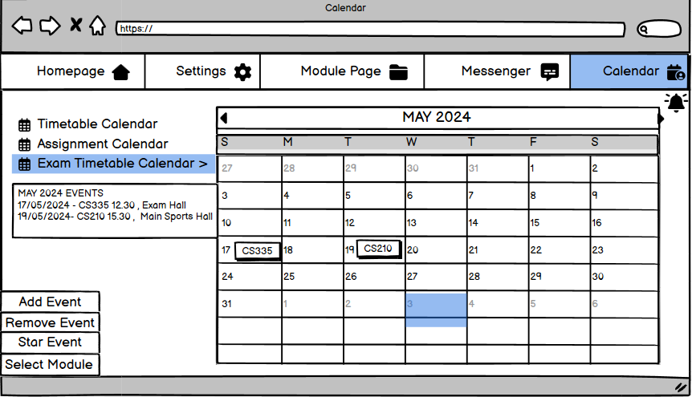

Fig 8.5 Calendar Page

System Tests

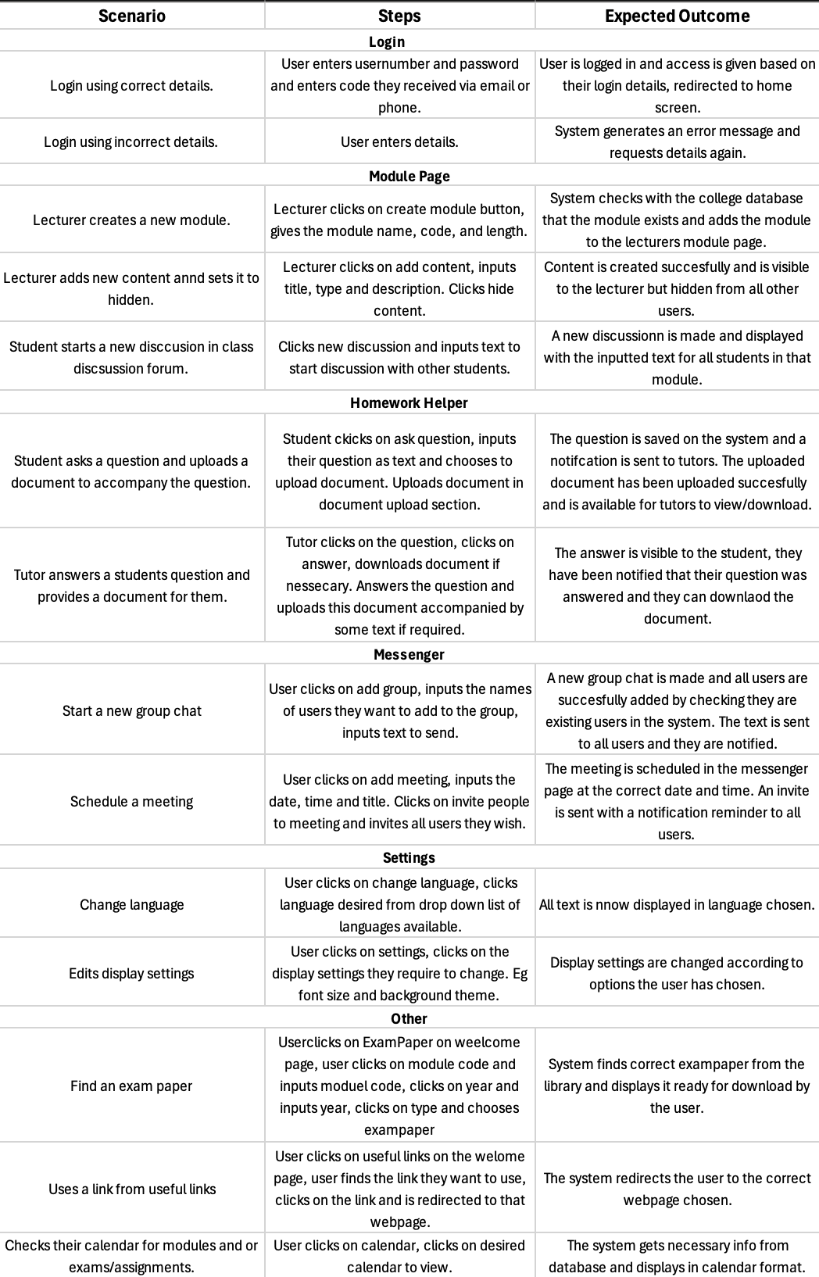 Fig 9.1 Test cases for various aspects of the webpage